CINELINK FILM SERVICE

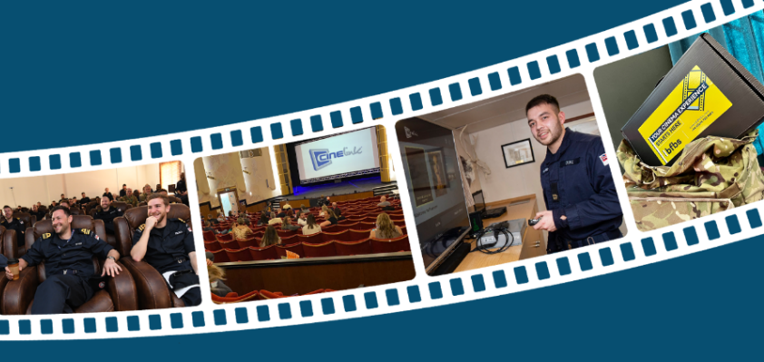
The BFBS Cinelink Film Service allows military communities based in the UK and Overseas the opportunity to host movie nights with the latest film releases. This portable media player is an innovative system that will allow encrypted early release film content to be shown onto a screen via a projector or television which has an HDMI port. HD quality films are typically licensed for screening within 6–8 weeks of their UK cinema release

With this system, units can legally show films that have recently been released into UK cinemas. Allows you to gather everyone together regularly for that shared viewing experience turning your mess, welfare hub or community venue into your very own cinema with Cinelink.

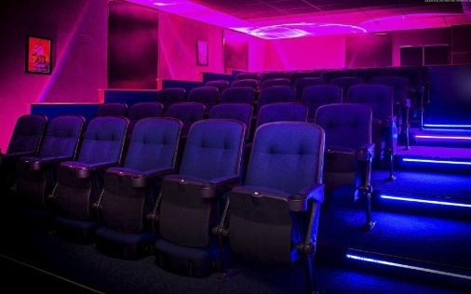
Who is entitled to the Cinelink Film Service?

The service is provided exclusively for an entitled audience of members of HM Forces, MOD civilians, and their families who are based in remote locations, operational theatres, or places unable to sustain digital cinema facilities.

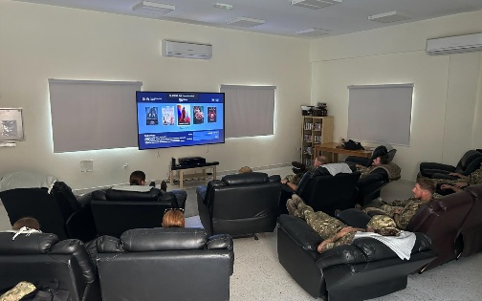
Military locations across the UK and overseas will qualify based on their individual circumstances. These can include but are not limited to:
• Operational duty
• High intensity training/exercises
• Phase 1 & 2 Training
• Confined to Barracks
• Decompression
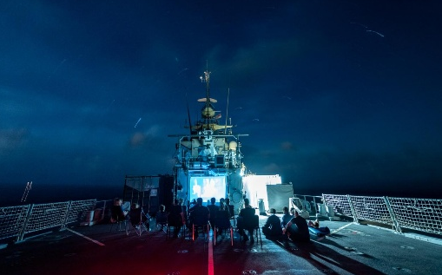
• Where families are disadvantaged by geography
• Watch-keeping or long shifts confined to a named location
• Prolonged 'notice to deploy' or 'operational ready' state

Military units may additionally support Veteran communities within their communal spaces, with
prior permission from BFBS.

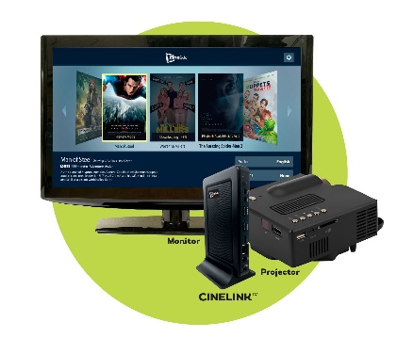
What equipment is required?

Units need to supply either HD-compatible HDCP projection equipment or a television with an HDMI port which should be set up in a room/space that is suitable for communal viewing. Additional equipment may be required to appreciate the HD picture and surround sound. The player is portable and can be moved to different screening locations very easily.

Once units have signed up to the service, BFBS Cinemas will despatch the Cinelink equipment which includes a set-top box, power cable, HDMI cable, ethernet cable, remote control, and user instructions. Please note: the Cinelink equipment is leased to the unit. It must be stored safely and securely when not in use, must not be lent to other users and must be returned to BFBS at the end of the agreement period.

How many films are supplied and how are they received?

BFBS Cinemas will arrange for units to receive films either on an encrypted USB stick or via download. Each player will receive up to 52 titles per annum, dependant on their package type. BFBS will select the films (see below) and they will be dispatched/downloaded as soon as they become available. Negotiation and procurement of films via the Cinelink service rests solely with BFBS. If sites are to screen any additional content outside of the BFBS Cinelink service, licensing of content is essential and is the sole responsibility of the military unit.

New-release films should be available 6-8 weeks after initial release in UK Cinemas however this can vary earlier or later, depending on the studios.

BFBS will advise which film titles have been booked, along with despatch details for those units receiving content by USB stick; films will be sent as soon as they are available to UK or BFPO addresses. Films will automatically be downloaded to Cinelink players that are connected to the internet with BFBS notifying of their availability.

All films provided by BFBS are encrypted and will only play on a BFBS Cinelink player. Each title is licenced for 20 weeks and will be available for playback for unlimited screenings until the expiration date. Please note: Cinelink is not a video-on-demand service; it does not stream content over the internet; films are downloaded and saved on the Cinelink player internal storage. Films must be completely downloaded before they can play and once loaded the USB stick must be returned to BFBS.

BFBS also provides marketing materials in the form of print posters and flyers to help you promote your film nights. Please speak with the team to discuss any specific marketing requirements for your venue and we’ll be happy to support where we can.

How are films selected?

BFBS Cinemas will choose film titles based on their overall popularity and availability. We also welcome suggestions from units for future film titles.

Family Service: Up to 52 films per year selected for a family audience

Non-Family Service: Up to 52 films per year selected for an older audience i.e. Operational Duty

Select Service: 12-52 films per year (dependant on agreed package), content chosen by each site from a selection provided by BFBS monthly. (*Only available to sites able to download content)


With Select, you can also choose from a classic film library provided by BFBS. This provides you the flexibility to curate the perfect programme for themed events that bring your community together. This could be screenings with family favourites around Christmas or Halloween, or all-time classic movie events – getting to see some of the best films back on the big screen.

All films rated by the British Board of Film Classification are eligible for consideration and release by BFBS. It is a requirement for you to abide by the age restrictions imposed by the BBFC and ensure that child admissions to film screenings take place in accordance with the film’s age classification rating.

18 Suitable only for 18 years and over
15 Suitable only for 15 years and over
12A May be unsuitable for children under 12 who must be accompanied by a
person of 18 years or over
PG May be unsuitable for children under 8
U Suitable for all.

BFBS does not censor films. All films are the original versions procured direct from the studios. Units may choose not to show a specific film but may not delete or edit any part of a film chosen for exhibition.

How much does it cost?
The Cinelink Service, fees and early release windows have been negotiated and licenced specifically for HM Forces, MOD Civilians and their families to exhibit non-commercial screenings within military establishments or premises that can be managed to permit only the entitled personnel. Non-commercial screenings are defined as screenings where no admission charge is made.

Option 1 - Up to-52 films per annum (content delivery via USB and download)
Typically available within 6-8 weeks of UK cinema release
£5,170 (plus VAT where applicable) per annum

Option 2 – 24 films per annum Select package (content delivery via download only)
Typically available within 6-8 weeks of UK cinema release
£2,895 (plus VAT where applicable) per annum
Option 3 - 12 films per annum Select package (content delivery via download only)
Typically available within 6-8 weeks of UK cinema release
£1,448 (plus VAT where applicable) per annum

These costs include the lease of the Cinelink viewing equipment (player, cables, remote control, carry box and user instructions).

There are price reductions for subsequent years for renewal of service. Please contact BFBS to discuss a specific quote, including payment methods.

Who pays for the service?
Units will need to secure funding for this service. This may come from welfare funds, grants, non-public sources e.g. PRI or local gain share, or profits from sales of food and drinks associated with film screenings.

Units may not charge an admission fee to view the films, however, it is possible to recoup licencing fees, if required, via a ‘Film Club’ arrangement. More information about setting up and running a film club is available from BFBS Cinemas.

There may be additional charges incurred for some payment methods. Please discuss these with BFBS at the time of making your application.

How do I apply for the Cinelink film Service?
Please complete the application form and return it to BFBS Cinemas, contact details below.

For more information or additional questions relating the service, equipment, agreement terms or to discuss setting up a film club contact BFBS Cinemas by email, cinelink@bfbs.com.

